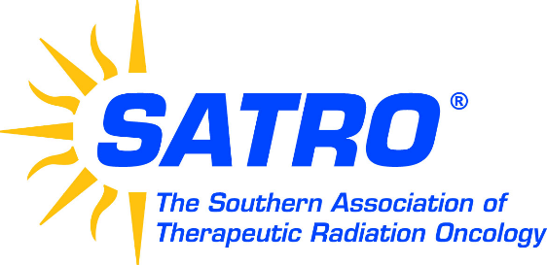

SPONSORSHIP LEVELS
2020 CONFERENCE
ATLANTA, GEORGIA
April 23-24, 2020

TITANIUM* $10,500+ CONFERENCE SPONSORSHIP
(includes sponsorship of an educational session)

PLATINUM* $7,501 - $10,000 SPONSORSHIP OF LUNCHEON

GOLD $5,001 - $7,500 SPONSORSHIP OF CONTINENTAL BREAKFAST

SILVER $2,501 - $5,000 SPONSORSHIP OF REFRESHMENT BREAK (3 AVALABLE)

BRONZE $1,000 - $2,500 UNRESTRICTED SPONSORSHIP OF CONFERENCE EXPENSES

All Sponsors receive the following benefits:

Listing on the SATRO website
[Type a quote from the document or the summary of an interesting point. You can position the text box anywhere in the document. Use the Drawing Tools tab to change the formatting of the pull quote text box.]
Recognition on conference signage
[Type a quote from the document or the summary of an interesting point. You can position the text box anywhere in the document. Use the Drawing Tools tab to change the formatting of the pull quote text box.]
Listing in conference media distributed to attendees
[Type a quote from the document or the summary of an interesting point. You can position the text box anywhere in the document. Use the Drawing Tools tab to change the formatting of the pull quote text box.]
Attendee mailing lists prior to the conference
[Type a quote from the document or the summary of an interesting point. You can position the text box anywhere in the document. Use the Drawing Tools tab to change the formatting of the pull quote text box.]

*In addition, Titanium and Platinum level sponsors include a free vendor booth including registration for two attendees

For more information, contact SATRO Directors
Marcia Phillips, Marcia.Phillips@northside.com or
Paul Williams, mysatro@aol.com
P.O. Box 2496 . Matthews, NC 28106
P: 877-559-4548 E-mail: mysatro@aol.com

